Mirto 2023 Build Information

This document describes the CS (Raspberry Pi/Teensy) and Arduino variants of the Mirto robot.

Either robot can be built with or without bump or IR sensors.

Document Version 0.1 (draft)

Last updated May 2 2023 by Michael Margolis

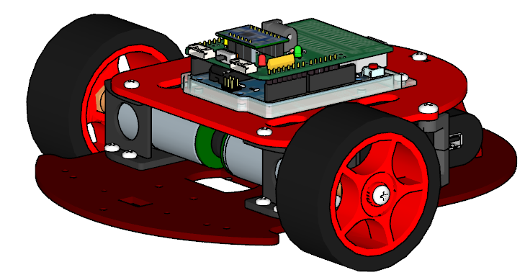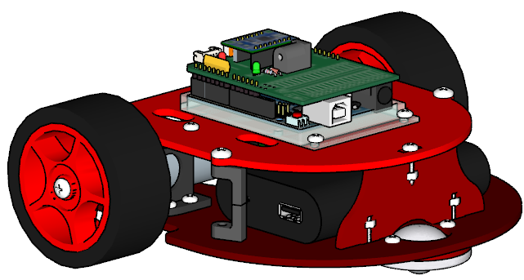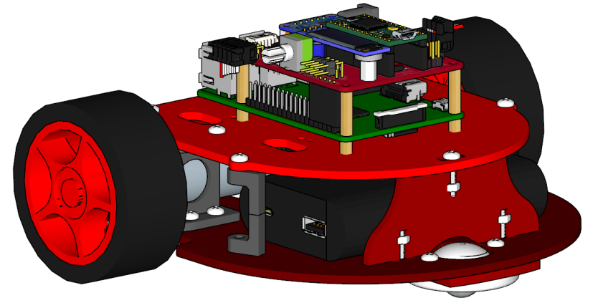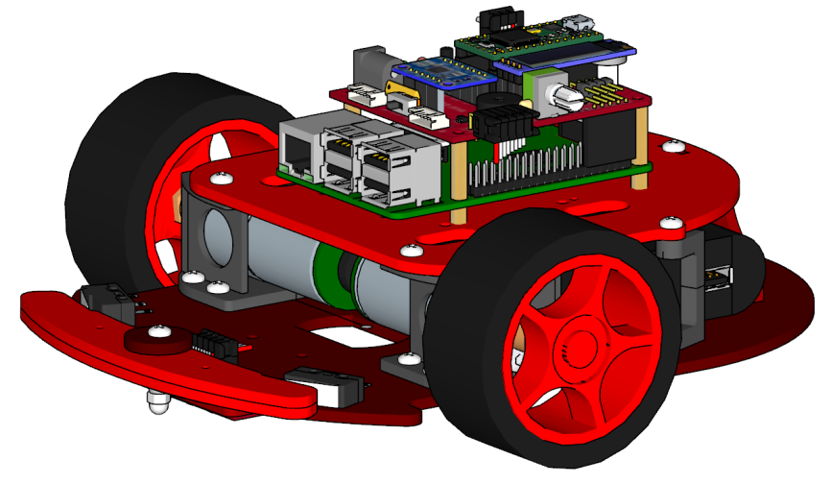Robot Components (see Electronic Assembly Section for wiring and electrical parts not shown).

Figure 2: Arduino WiFi R2

Figure 1: CS Mirto with bump and IR sensors

Supplier part numbers for hardware and electronic components can be found at: https://github.com/michaelmargolis/Mirto2023/tree/main/docs/Mirto_BOM.xlsx

Note orientation of top and bottom plates, left side indicated by letter L

**Figures are not to scale**

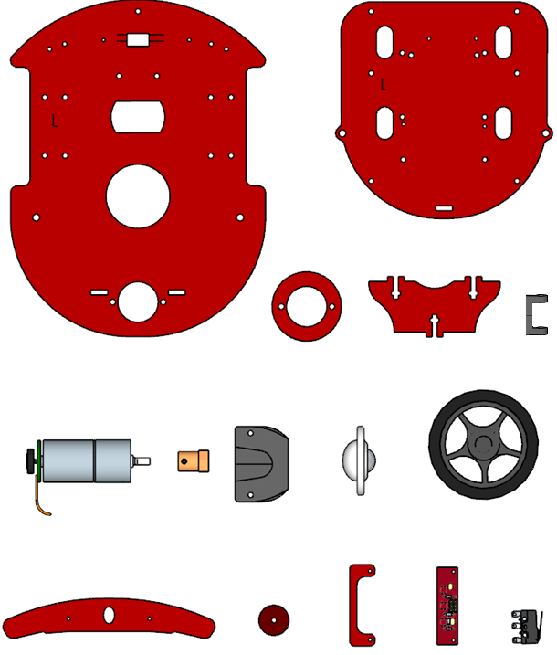

Bumper x2

Bumper

Cap

Switch X2

IR Sensor Board

IR Sensors

Spacer x2

Caster

Wheel x2

Offset Spacer

Upper Plate

Bottom Plate

Caster Spacer

Rear bracket

Motor x2

Hub x2

Motor Mount x2

**These parts are only required for robots with Bump and IR Sensors**

Hardware for core robot:

|  |  |  |
| --- | --- | --- |
| Quantity | Description |  |
| 4 | M3 x 5 socket button screw |  |
| 2 | M3 Grub screw |  |
| 12 | M3 X 10 pan head machine screw |  |
| 5 | M3 X 12 pan head machine screw |  |
| 19 | M3 nut |  |
| 4 | M4 X 8 pan head machine screw |  |

Arduino Robot controller mounting hardware (For Arduino Uno Wifi and PCB)

|  |  |  |
| --- | --- | --- |
| Quantity | Description |  |
| 4 | M 3 x 8 pan head machine screw |  |
| 4 | M 3 nut |  |

CS Robot mounting hardware (for Raspberry Pi and Mirto PCB)

|  |  |  |
| --- | --- | --- |
| Quantity | Description |  |
| 8 | M2.5 x 12 pan head machine screw |  |
| 4 | M2.5 x 4 threaded standoff for Pi |  |
| 4 | M2.5 x 16 threaded standoff for Mirto PCB |  |

Additional hardware for robot with bump sensors

|  |  |  |
| --- | --- | --- |
| Quantity | Description |  |
| 1 | M3 X 20 socket button screw |  |
| 1 | M3 locknut |  |
| 1 | Nylon dome nut |  |
| 4 | M2.5 x 12 pan head machine screw |  |
| 4 | M2.5 nut |  |

Additional Hardware for robots with IR Sensors

|  |  |  |
| --- | --- | --- |
| Quantity | Description |  |
| 2 | M2 X 12 pan head machine screw |  |
| 2 | M2 nut |  |

Additional Hardware for robots with Waveshare 1.14 inch IPS-TFT-LCD Display (SKU 18231)

|  |  |  |
| --- | --- | --- |
| Quantity | Description |  |
| 4 | M3x5 machine screw |  |
| 4 | M3 nut |  |

**Build notes:**

* **Read through all steps before beginning assembly**
* Double check hardware before each assembly step and make sure that the length of the screw matches the instructions.
* Look at the prototype if you are not sure how things go together
* Don’t overtighten the screws
* Machine screws are pan head where not specified.
* Use thread lock only after initial assembly

If not already fitted, insert M3 nut into slot on hub and hold in place with grub screw

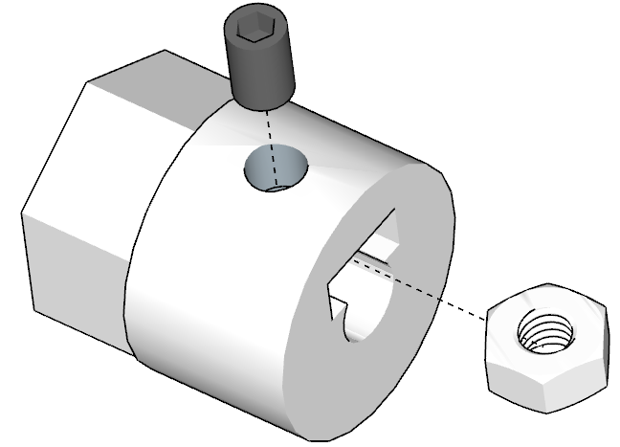

Figure 3A: Hub Detail

Attach motors to mount using M3x5 button head screws. Don’t overtighten these screws.

Note left and right motor positions are mirror images.

**Caution – you must use the M3x5 hardware specified, longer screws will damage the gearbox!**

Hardware: 2 off M3 x 5 socket button screws for each motor

2 off M3 grub screws and M3 nuts for hubs

Mount motors so wires face towards the rear when mounted on the bottom plate

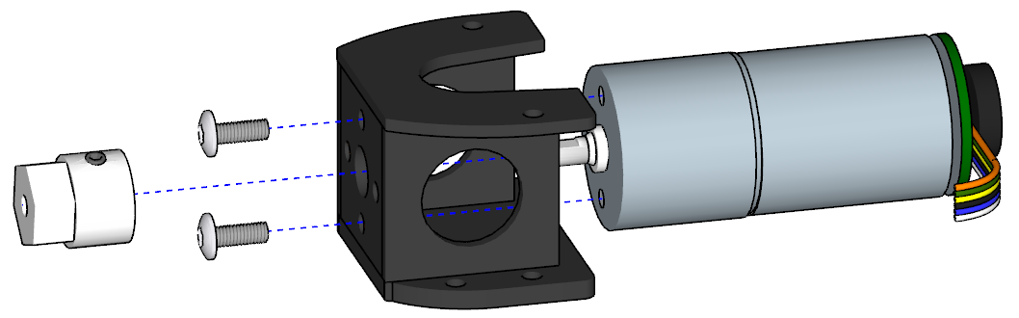

Figure 3B: Motor Mount

Attach hub. There should be a slight gap to avoid touching motor screws

The motor brackets are attached to the bottom plate with the motor wires facing to rear of the robot. Important: Orient base plate so letter L is on the left side of robot as shown in the figure

Hardware:

8 off M3 x 10 pan head machine screws and nuts

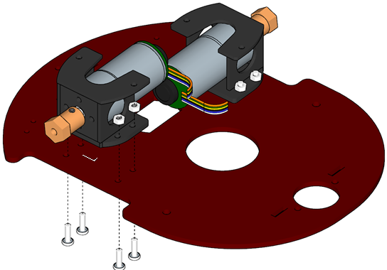

Figure 4: Mounting motors

M3 X 10 machine screws

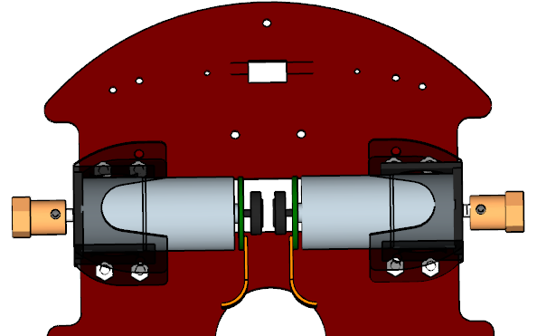 Important: Ensure motors are mounted so both motor wires extend to rear of robot

Attach the Standoffs, rear bracket and caster.

Hardware:

4 off M3 x 12 pan head machine screws and nuts

2 off M4 x 8 pan head machine screws

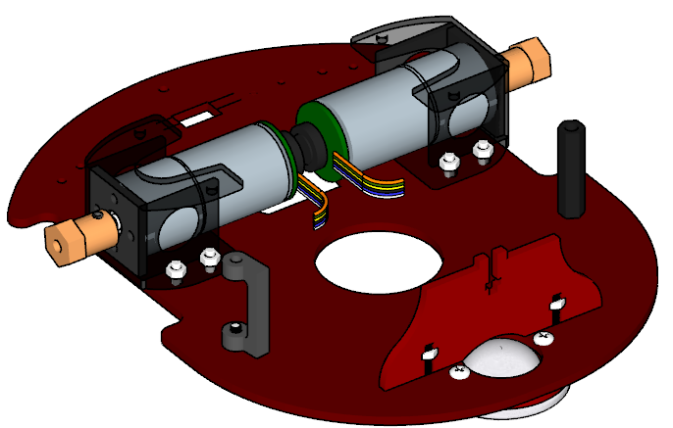

M3 X 12 machine screws and nuts

M4 X 30 Standoff attached from bottom using M4 X 8 machine screw

Offset Standoff attached using M4 X 8 machine screw from bottom

Figure 5A: Component Location on bottom frame

Figure 5B: Bottom frame detail - Note the location of the caster spacer

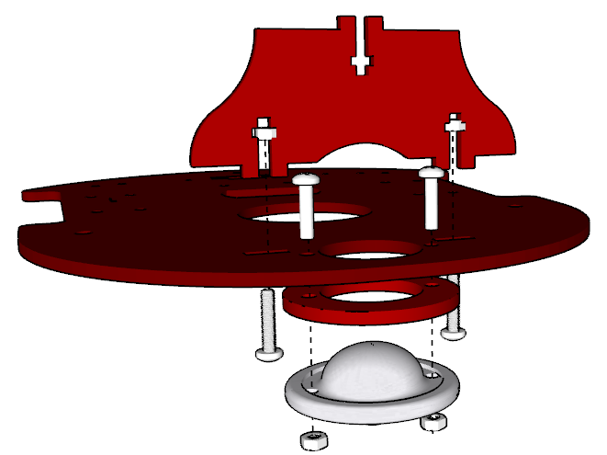

Skip this page if building the robot without bump switches or IR Sensors.

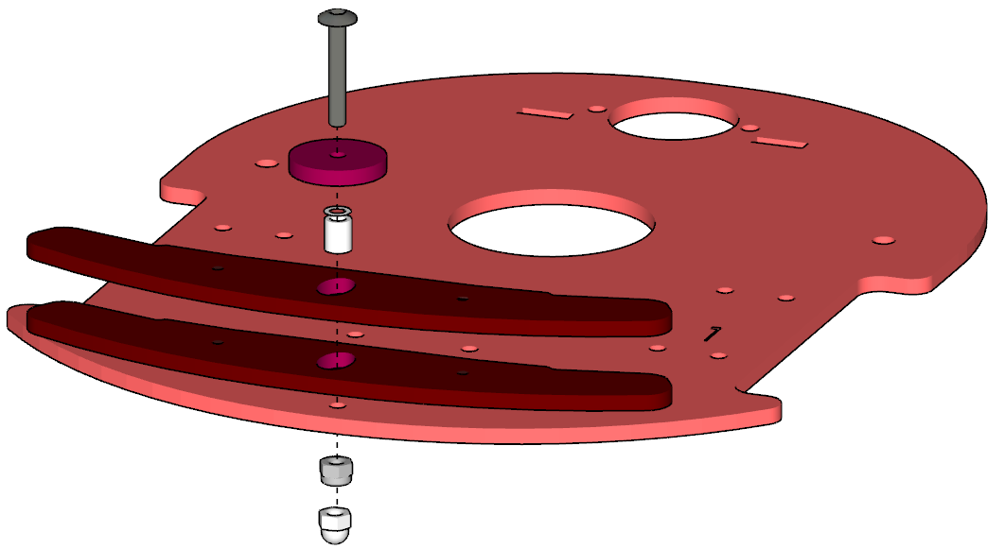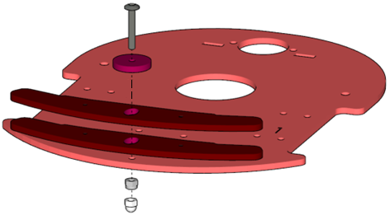Attach two bumpers to the lower plate using a 20mm M3 hex machine screw and nyloc nut. The nyloc nut is metal with a nylon insert that resists turning; you will need to hold this nut with pliers when tightening the screw with a hex key until there is just enough play to allow free movement of the bumpers . The plastic dome nut is then screwed onto the bottom to act as a skid to prevent the robot tipping forward and damaging the IR sensors

Figure 6A: Location of Bumper mounting hardware

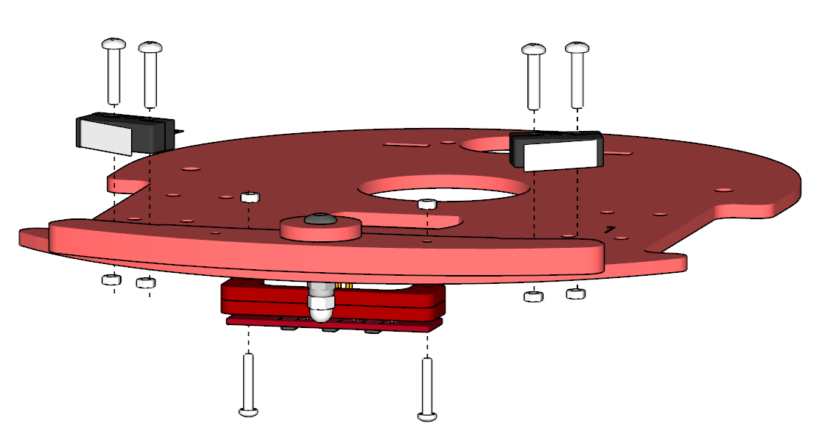

Figure 7: Mounting bump switches and IR sensors

Note the orientation of the switch levers (the hinges on both switches are towards the outside of the plate)

Bump Hardware:

1 off M3 x 20 socket button screw

1 off M3 plastic washer

1 off M3 6mm spacer

1 off M3 lock nut

IR sensor Hardware:

4 off M2x12 pan head screws

4 off M2 nuts

1 off M3 plastic dome nut

4 off M2.5 x 12 pan head screws

4 off M2.5 nuts

Assembling the Raspberry PI version (see next page for Arduino version):

**Microcontroller variants**

Mirto supports a variety of microcontroller options. The desired option is implemented by attaching the electronics to the top plate. See the relevant section of appendix A for mounting instructions:

**CS Mirto using Teensy 3.2 board and Raspberry Pi**

* Teensy drives robot hardware
* Pi supports robot logic in high level language (python, racket etc)
* Communication between teensy and Pi using ASIP protocol (see ASIP 1.2 repo)
* two legacy PCBs are supported:
  + Mirto2016 board that uses Toshiba TB6612FNG H-Bridge
  + Mirto2018 board using TI DRV8833 H-Bridge

**CS Mirto using Pico 2040 and Raspbery Pi**

* similar to above but using Pico instead of Teensy

**Outreach Mirto using Pico WiFI**

* Uses same Pico PCB as CS pico but without Raspberry pi
* ASIP protocol over WiFI connects to Scratch or similar

**Outreach Mirto using Arduino Wifi R2**

* Uses custom shield for H-Bridge and other robot hardware support
* ASIP protocol over WiFI connects to Scratch or similar

**Standalone Mirto**

* This comprises any of the above without the Raspberry PI
* Robot logic onboard in C++ or micropython depending on microcontroller

The electronics should be attached at this time following the appropriate information in **Appendix A.** After this the top plate is attached to the chassis limiting access to the underside of the top plate.

Small pieces of Velcro can be used to hold the battery to the bottom plate to prevent sliding around when moved. Locate the battery on the bottom plate ensuring the charging and output connectors 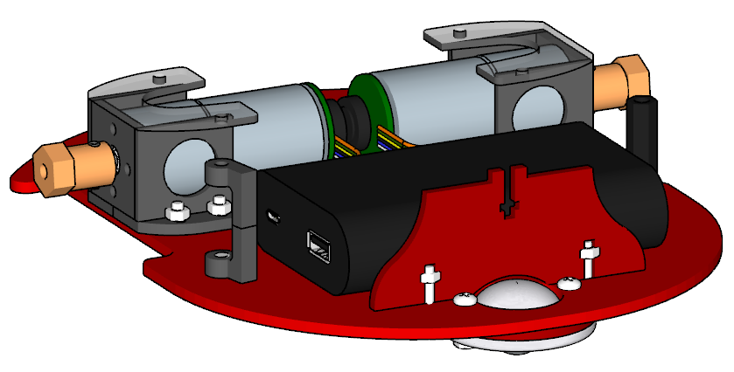are accessible.

Figure 10: Battery location

Attach the top plate using four machine M3x10 screws and nuts into the motor mounts and two M4x8 screws into the rear standoffs.

Hardware:

4 M3 x 10 machine screws

1 off M3 x 12 machine screws

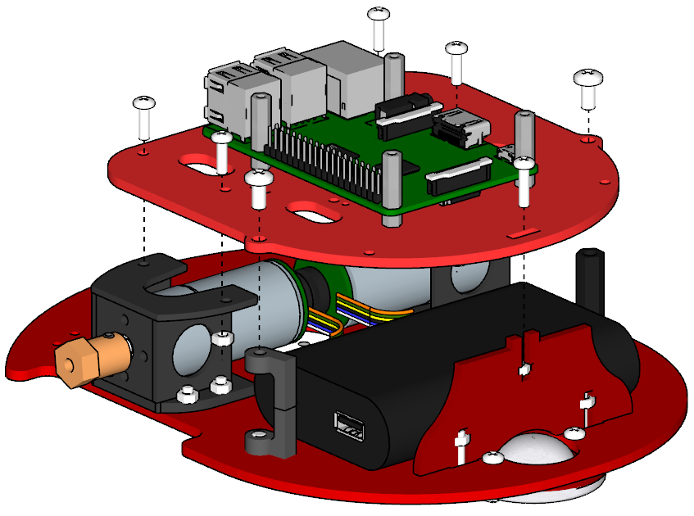5 M3 nuts

2 M4 x 8 machine screws

Figure 11: Attach top plate

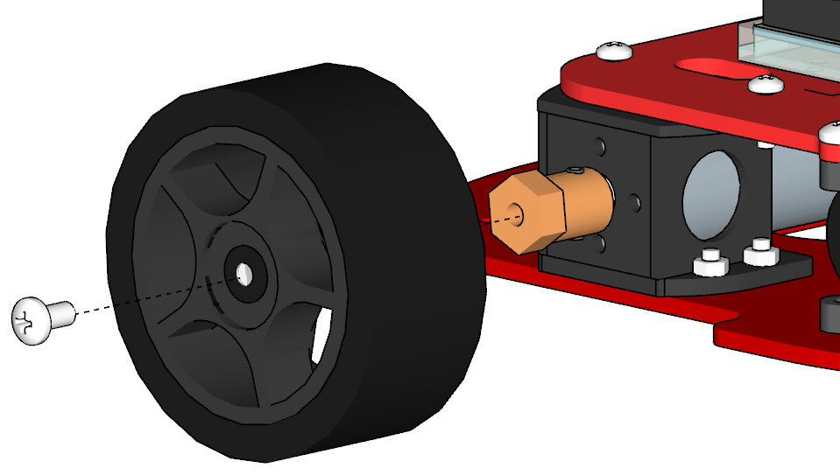Push the wheels onto the hubs and attach with M4X8 machine screws

Hardware:

2 M4 x 8 machine screws

Figure 11: attach wheels

**Appendix A – Top plate electronics**

**CS Mirto using Teensy 3.2 or Pico board and Raspberry Pi**

Attach four M2.5X4 spacers using M2.5X12 machine screws. Note the location of the holes as shown in figure

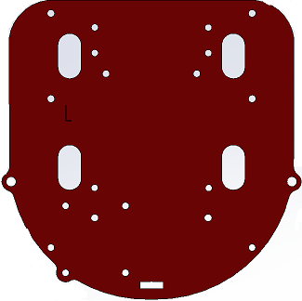

Figure 8A: Mounting standoffs for the Raspberry Pi

Figure 8B: Location of Raspberry Pi mounting holes

The Raspberry pi is inserted onto the screws and held in place using four M2.5X16 threaded standoffs. The Mirto2020 PCB is plugged into the Pi and secured using four M2.5X12 machine screws.

Figure 8C: Raspberry Pi positioned on standoffs

Figure 8D: Mirto circuit board on top of Pi

Hardware:

4 M2.5 x 4 standoffs

4 M2.5 x 16 standoffs

8 M2.5 x 12 machine screws

Boards that do not have build-in LCD display are attached to the top plate using the hole positions shown below:

Teensy .96 OLED LCD mounting position. Teensy 1.3 OLED LCD mounting position.

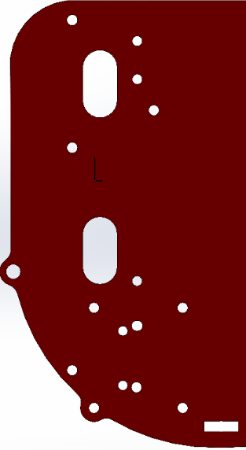

Pico board color LCD mounting position.



Assembling the Arduino version:

Attach the Arduino mount using four M3x8 machine screws and nuts. The mount is supplied with Arduino Uno WiFi rev 2 or can be ordered from Arduino supplier as part number X000019.

The Arduino board and Mirto PCB can be press fitted to the mount after assembling the robot.

Hardware:

4 M3 x 8 machine screws

4 M3 nuts

Figure 9A: Location of mounting holes for Arduino mount

Figure 9B: Attaching Arduino mount

Figure 9C: Arduino and motor shield located on mount

**Appendix B - Electronic Assembly and Wiring Information**

The IR Sensor Connector Board is made by inserting three IR sensors from the underside of the board. Three 47K resistors and one 47 ohm resistor are placed on the upper side of the board. Solder two 0.1 uF ceramic capacitors and the 2x3 connector as shown below.

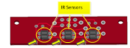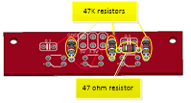

Yellow arrows points to orientation notches

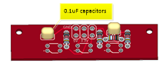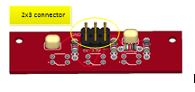

Figure 12: IR Sensor Connector Board

The IR sensors are connected to the main circuit board using a 6 conductor IDC cable.

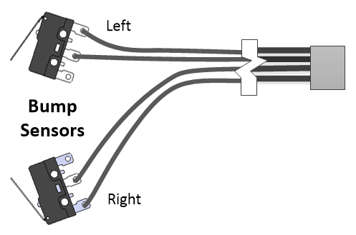The bump switch assembly is made by soldering 20 cm of four conductor ribbon cable to the switches as shown. The other end is crimped into a 2x2 IDC ribbon connector.

Figure13: Bump Switch Wiring

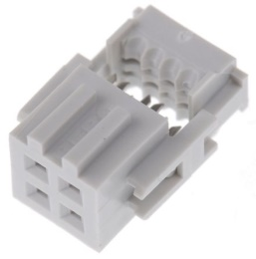

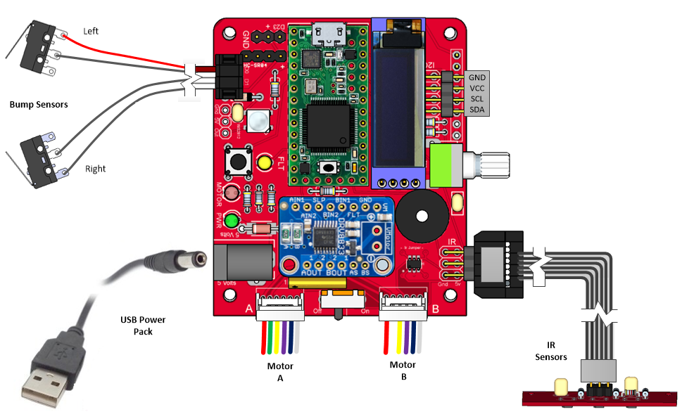

Figure 14: Wiring the Mirto 2020 board for Raspberry Pi

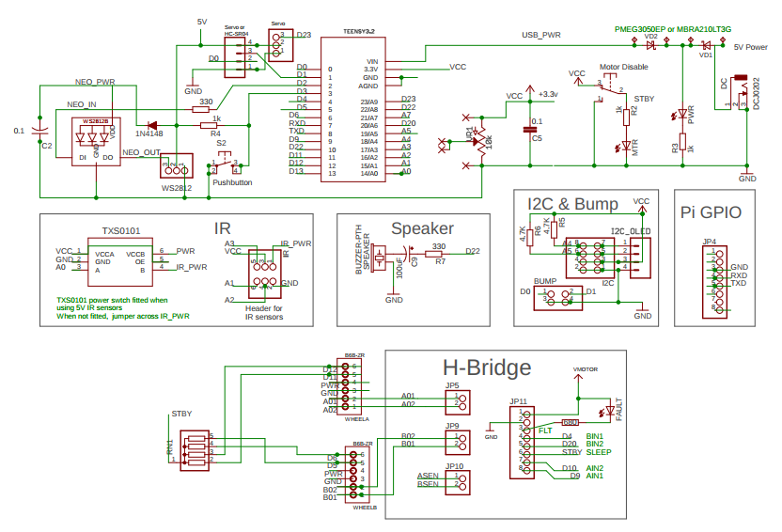

Figure 15: Schematic Diagram

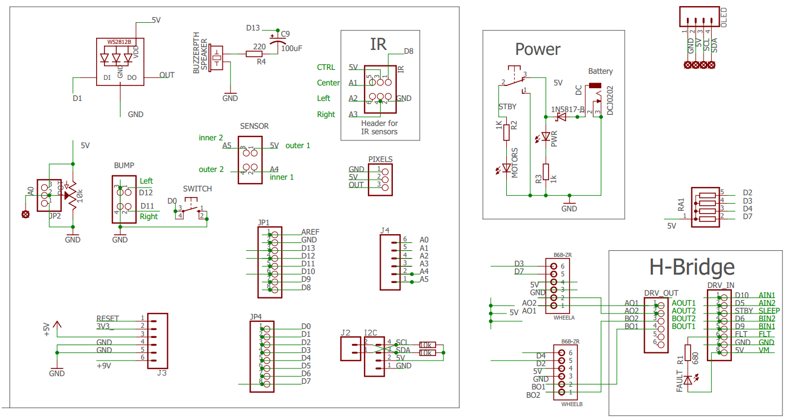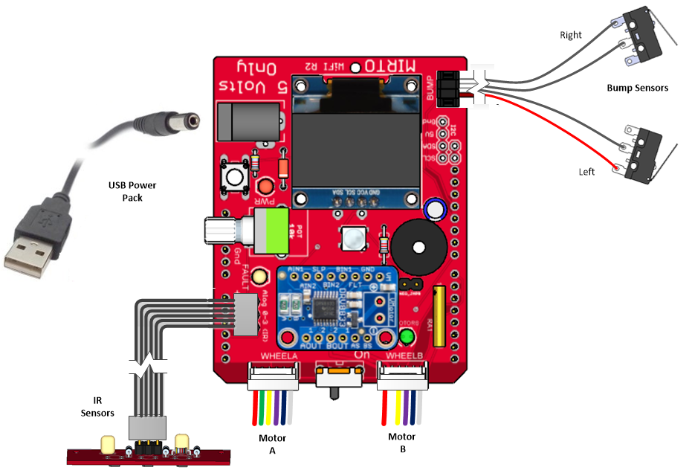

Figure 17: Schematic Diagram

Figure 16: Wiring the Mirto Wifi R2 board

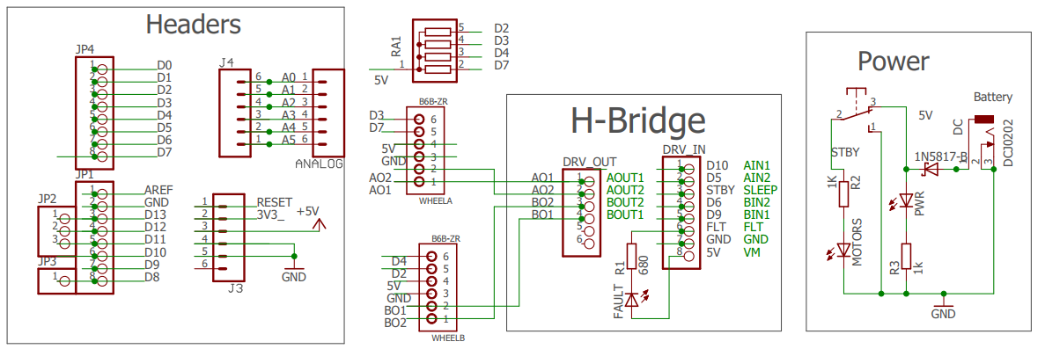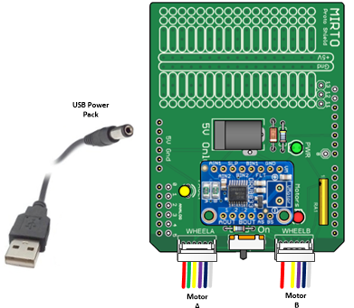**Appendix C - Motor Details**

The specifications for the motors measured at 6 volts are as follows:

NO LOAD:

Current: < 0.15 Amps Max

Speed: 197±10%rpm

ON LOAD :

Torque: 0.7kg.cm

Current: < 0.54A Max

Speed: 158±10%rpm

STALL:

Current: < 2.87 Amps

Torque 4kg.cm

Gearbox Ratio 1:34

Maximum Motor Drive Voltage: 8.4 Volts

